|  |  |
| --- | --- |
| **Assignment Case** |  |
| COMP6175 | T0044  Object Oriented Programming |
| **Computer Science** | **E203-COMP6175-RH06-01** |
| ***Valid on*** *Even Semester Year 2019/2020* | **Revision 00** |

## Soal

*Case*

**RHanet**

**RHanet** is a popular internet café. Mr. Baki, as the owner of **RHanet** wants to make the application to manage customer. You as a programmer are asked to make **RHanet management system** using **Java Programming Language** with the following specifications:

First, the program will print **main menu** that consists of:

1. **Add Customer**
2. **View Customer**
3. **Extend Time**
4. **Exit**

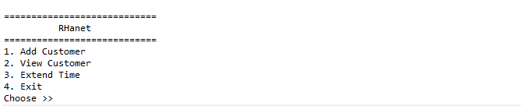

1. If the user chooses **Add Customer (Menu 1)**, then:
   * The program will ask the user to **input** the following data:
     + **Customer’s titles**, which is **between** “**Mr.** ” **or** “**Mrs.** ” (case sensitive).
     + **Customer’s name**, which **length** is **between 1 and 30 characters**.



* + - **Time’s duration,** which is **between 1 - 5 hours**.
  + After that, the program will **generate Customer’s ID**. Validate the **generated ID must be unique** and follows the following format:

**CUXXX**

**Where:**

**X = Random Number 0-9**

**Example: CU123**

* + Finally, the program will **save the customer** into the customer list and printsuccess message

1. If the user chooses **View Customer (Menu 2)**, then:
   * If **customer list is empty**, then **show message “No data !!”**



* + Otherwise, **show all customer data** in the list

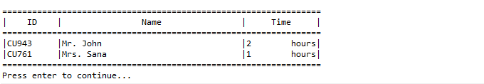

1. If the user chooses **Extend Time (Menu 3)**, then:
   * If **customer list is empty**, then **show message “No data !!”**



* + Otherwise, do the following:
    - **Print all customer data** in the list.
    - Ask the user to **input customer’s ID**. Validate the **ID** must **exist** in the list (case sensitive).
    - 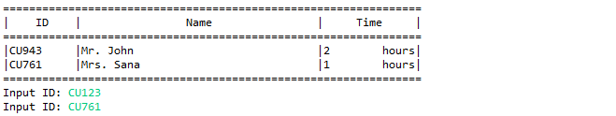Ask the user to input **time duration**, which is **between 1 - 5 hours**.Then, **update the time by summing the old time with the new one**.
    - After that, the program willshow the following message:

1. If the user chooses **Exit (Menu 4)**, the program will **exit** and print the following message:



**Please run the EXE file to see the sample program.**